|  |  |  |  |  |
| --- | --- | --- | --- | --- |
|  |  | |  | | --- | | Troy Athletic Field Meet | | Issue Date | |
|  |  |  |
| sports day |  | In This Issue |

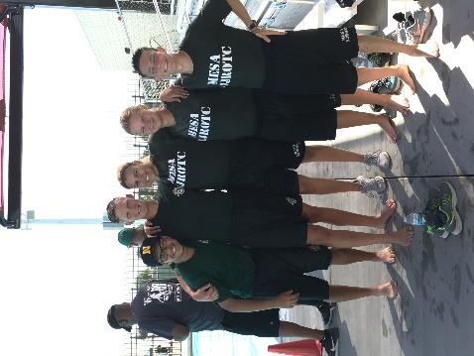

“Pain is weakness leaving the body “, the words we live by in a fun and exhausting meet like this. Troy Athletic Field Meet, held at Troy High School, located in Fullerton, California, is one of the best and major events our Ram Battalion looks forward to every year. This is the day units can prove how hard they worked on practicing and how bad they want that trophy.

Murrieta Mesa’s Ram Battalion puts in a lot of work to accomplish what we want. When we have a goal, we don’t just attain the goal, we go above and beyond to prove we did it the best and that we are the best. Practices were held every day throughout the week, for a month, depending on what event the cadets were in. Our unit put on our game faces to win the trophies we wanted and will give it our all.

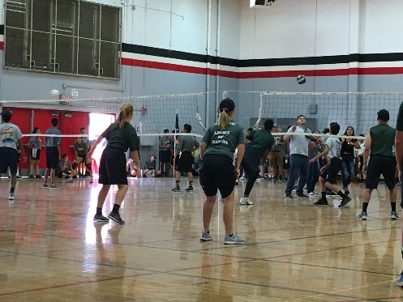Troy High School is the best campus to have this kind of event at. Around 32 schools went and participated in the meet, with teams for each event. This event has the biggest selection for awards, which motivates everyone more. After a long day of sunburns, sweat, need for water and food, we all packed inside the gym and we received our awards:

1. Best Spirit Award – Ashley Guerrero and Claire Leon
2. Boat Relay placing 3rd -Jonah Sanchez
3. Rope Bridging placing 5th – Caleb Cassida
4. 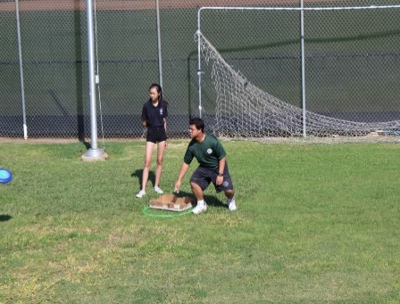Frisbee Golf placing 5th – Daniel Fahmy

# Troy Sports Day

by Amy Guerrero

Boat Relay

Jonah Sanchez(captain), Ashley Guerrero, Daniel Fahmy, Sarah Casas, Walter Taite.

Rope Bridging

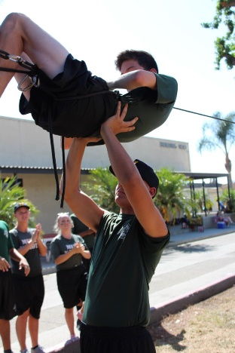Caleb Cassida(captain), Savanna Carrera, Ethan Sanchez, Nick Vicencio, Xavier Rose, Walter Taite